How to Set Up and Manage Subcontracting in Odoo 19 – Complete Workflow Guide
Rohan Raj | Feb 25, 2026
Subcontracting is a manufacturing strategy where a company hires an external party to produce goods on its behalf. This is common in industries where businesses prefer to outsource certain production steps due to capacity limitations, lack of specialised machinery or the need to focus on core operations. In Odoo 19, the subcontracting workflow is fully integrated with the Manufacturing, Purchase and Inventory applications, allowing businesses to manage outsourced production with complete visibility over components, transfers and costs.

Understanding Subcontracting in Odoo 19
In Odoo, subcontracting is handled through a special type of Bill of Materials called a Subcontracting BoM. When a product has a subcontracting BoM, Odoo understands that the product is manufactured externally by a subcontractor rather than in-house. This means the company purchases the finished product from the subcontractor, while Odoo tracks the components consumed and the goods received in the background.
Odoo 19 supports two primary subcontracting methods depending on how the subcontractor obtains the raw materials.
Basic Subcontracting — The subcontractor sources all materials independently. The company simply purchases the finished product. No raw materials are sent from the company warehouse.
Resupply Subcontractor on Order — The company sends the required components from its warehouse to the subcontractor when the purchase order is confirmed. This method gives the company control over material quality and cost.

Enabling the Subcontracting Feature
The subcontracting module is not enabled by default. To activate it, open the Manufacturing application and navigate to the settings page.

Manufacturing Application => Configuration => Settings
Under the Operations section, enable the Subcontracting checkbox and click Save.
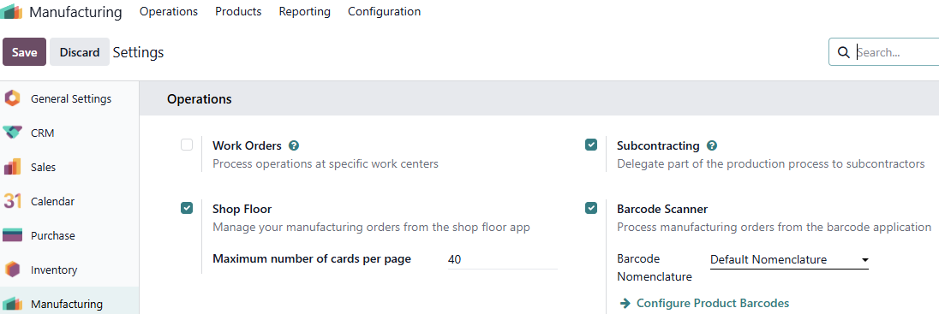
Once saved, two changes take effect. First, a new BoM type called Subcontracting becomes available when creating Bills of Materials. Second, a new stock route called Resupply Subcontractor on Order is created in the Inventory application. This route controls how components are sent to the subcontractor.

Creating the Subcontractor Contact
The subcontractor must exist as a contact in Odoo before they can be assigned to a subcontracting BoM or a purchase order.

Contacts Application => New
Create a new contact with the company name, address and phone number of the subcontractor. The contact automatically receives vendor status when it is assigned to a purchase order or a subcontracting BoM.
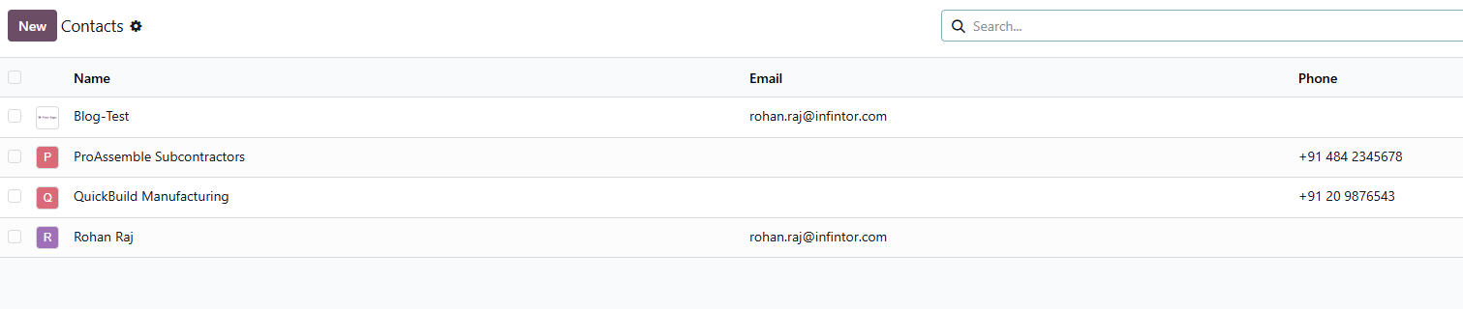
Creating multiple subcontractors allows the business to assign more than one vendor to a single BoM, providing flexibility when placing orders.

Creating the Product and Components
The finished product, that the subcontractor will manufacture needs to be created as a product in Odoo. This product must have the Can be Purchased option enabled because the subcontracting workflow is initiated through a purchase order.

Manufacturing Application => Products => Products => New
Create the finished product with the product name, cost price and sales price. Ensure that Can be Purchased is enabled on the product form.
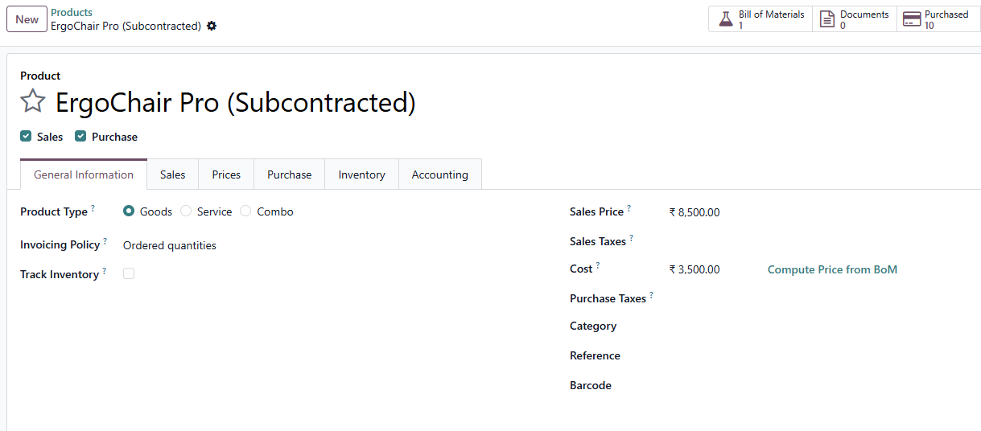
Each raw material or component required by the subcontractor must also be created as a separate product.

Creating the Subcontracting Bill of Materials
The Bill of Materials tells Odoo that this product is produced by a subcontractor rather than manufactured in-house.

Manufacturing Application => Products => Bills of Materials => New
On the BoM form, select the finished product. Change the BoM Type from Manufacture this Product to Subcontracting. In the Subcontractor(s) field that appears, add the subcontractor contact. Multiple subcontractors can be added to the same BoM if the product can be manufactured by more than one external party.
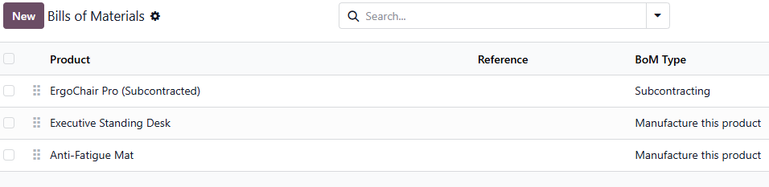
In the Components tab, add all the raw materials required along with their quantities. This tells Odoo exactly which components need to be sent to the subcontractor and in what quantities. If no components are listed in the BoM, Odoo assumes the subcontractor sources materials independently (Basic Subcontracting).
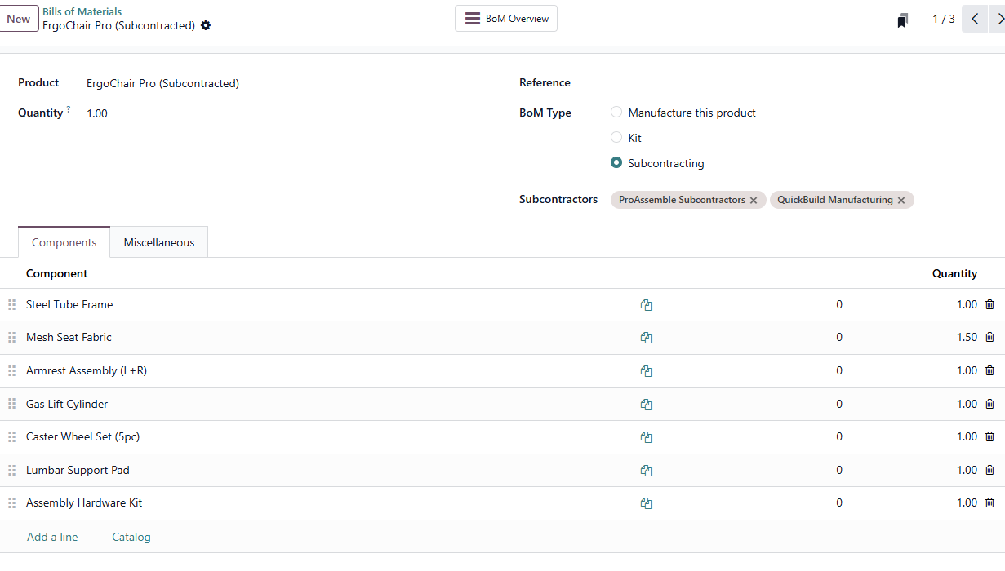

Adding Vendor Information to the Product
To quickly create purchase orders for the subcontracted product, vendor pricing should be configured on the product form.

Inventory Application => Products => Products => Select the Finished Product => Purchase Tab
Click Add a line under the vendor and enter the subcontractor’s name, unit price and delivery lead time.
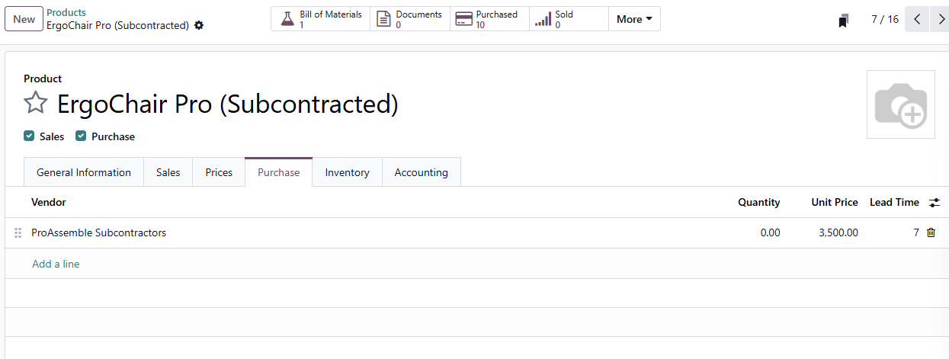

Executing the Subcontracting Workflow
With the configuration complete, the standard workflow is triggered by creating and confirming a purchase order for the subcontracted product. This is used when the finished goods need to be received back into the company warehouse.

Creating the Purchase Order

Purchase Application => Orders => Purchase Orders => New
Select the subcontractor as the vendor. Add the subcontracted product with the required quantity and unit price. Click Confirm Order.
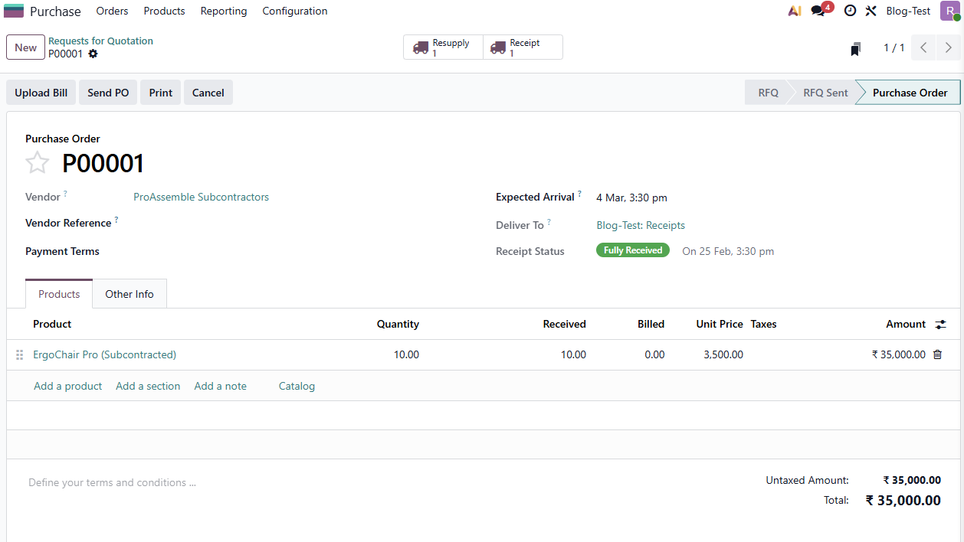

Transfers Created Automatically
After the purchase order is confirmed, Odoo automatically generates the required stock transfers based on the Subcontracting BoM configuration.
Odoo creates a Resupply Subcontractor transfer to send the required components from the company warehouse to the subcontractor location. Odoo also creates a Subcontracting Receipt to receive the finished product back from the subcontractor once manufacturing is complete.

Sending Components to the Subcontractor
Open the Resupply Subcontractor transfer from the purchase order or from the Inventory transfers list. This transfer contains all the component products with their required quantities. When the components are physically dispatched to the subcontractor, click Validate to confirm the shipment.

Receiving the Finished Goods
When the subcontractor completes production and ships the finished product, open the Subcontracting Receipt. Enter the quantity received and click Validate. The finished product is now recorded in the company warehouse and available for sale or further processing.
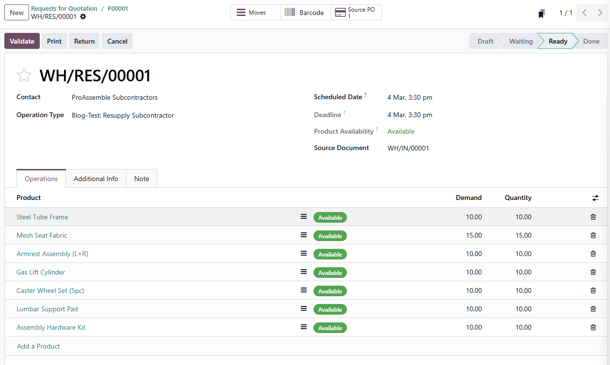

Understanding the Stock Movement
At the inventory level, the following transfers occur during the subcontracting workflow.
The Resupply Subcontractor transfer moves component products from the company warehouse to the virtual subcontractor location. The Subcontracting Receipt moves the finished product from the subcontractor location to the company warehouse stock location.
Odoo maintains a virtual subcontractor location to track components that are at the subcontractor premises. This provides a clear audit trail for inventory valuation.

Cost Tracking
The total cost of a subcontracted product includes the cost of components provided, the manufacturing fee paid to the subcontractor (the purchase price on the PO), and any shipping or logistics costs. This total is reflected in the product inventory valuation and flows into the accounting module for accurate financial reporting.

Dropshipping Finished Goods Directly to Customers
In the standard subcontracting workflow described above, the finished product is always received back into the company warehouse before being shipped to the customer. However, Odoo also supports a combined workflow where the subcontractor ships the finished product directly to the end customer, bypassing the company warehouse entirely.
To enable this, the Dropshipping feature must first be activated in the Purchase application settings. Once enabled, a Dropship route becomes available in the Inventory application.

Purchase Application => Configuration => Settings
Under the Shipping section, enable the Dropshipping checkbox and click Save.
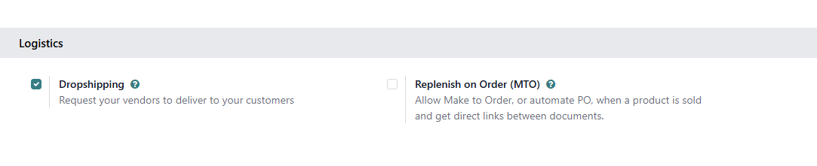
On the finished product form, open the Inventory tab and select the Dropship route. With this configuration, the workflow is triggered through a Sales Order rather than a Purchase Order. When a Sales Order is confirmed for the subcontracted product, Odoo automatically generates a Purchase Order to the subcontractor. Upon confirming that Purchase Order, two transfers are created — a Resupply Subcontractor transfer to send the raw materials from the company warehouse to the subcontractor, and a Dropship transfer to record the direct shipment of the finished product from the subcontractor to the customer.
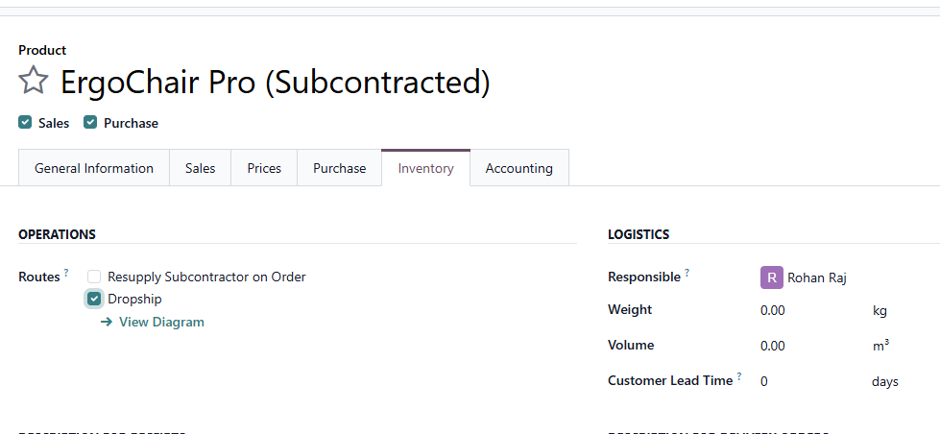
The company warehouse sends raw materials to the subcontractor, and the subcontractor ships the finished product directly to the customer. The finished goods never enter the company warehouse in this workflow.
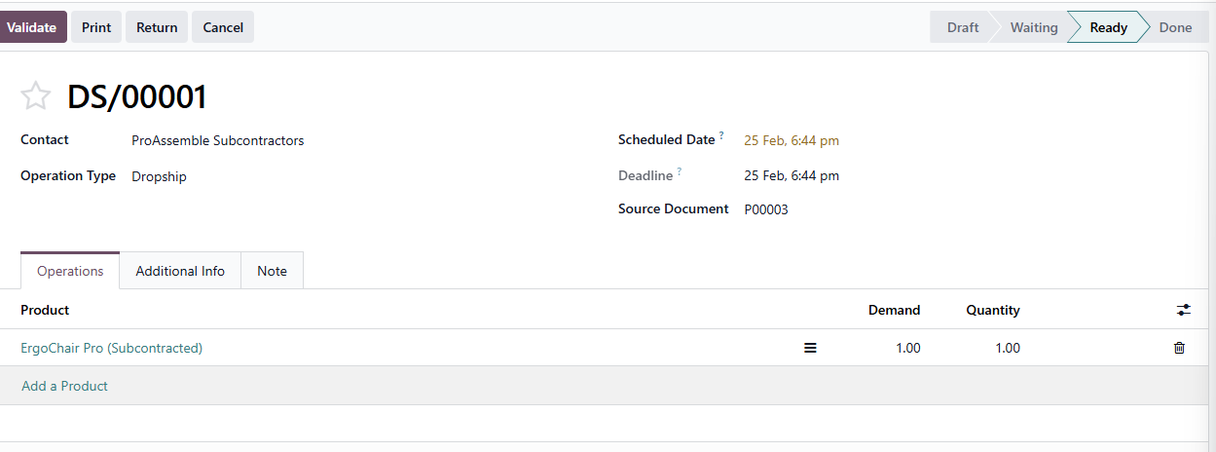

Conclusion
Subcontracting in Odoo 19 provides a fully integrated workflow for outsourcing manufacturing while maintaining complete control over components, stock movements and product costs. The process begins with enabling the subcontracting feature, creating a subcontracting BoM with the assigned subcontractor and components, and executing the workflow through a purchase order. For scenarios where the finished product needs to be shipped directly to the customer, the Dropshipping feature can be combined with subcontracting by triggering the workflow through a Sales Order instead.

